GENERAL
FIVE WAY MIRROR SCRYING EXPERIMENT

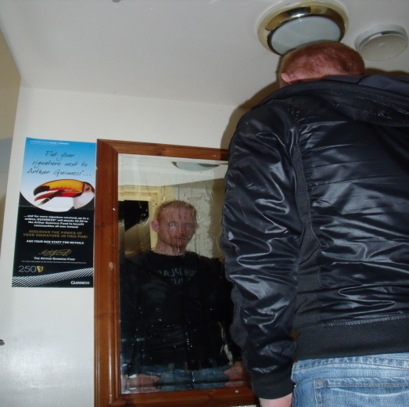
The art of scrying goes back many centuries. The object of this experiment is to evaluate five individual’s experiences (emotions, what they see, how they look in appearance) in a room/area by gazing into a mirror. The room/area may be 'active' or non- active' in relation to its history. The mirrors are set up in a circular shape facing inwards. The energy should be centred or at least in one view of the five individuals taking part.

BLOOD PRESSURE
How does your body react after an investigation or a vigil? The circulation of the blood through the wall vessels is measured by systolic and diastolic values. BP can change throughout the day though. This can be down to exercise, diet, stress and standing up for periods of time along with disease, drugs, smoking and alcohol. It is crucial to conduct the experiment at the start of the investigation or vigil, while rested and sitting down and measured again afterwards, rested and sitting down. Body temperature, tiredness, sickness and hunger can give different results too. Taking BP can help measure individuals’ responses to certain activity, excitement, fear, nausea, etc. before they enter a room/area or take part in an experiment. It is also a good idea to take a sphygmomanometer with your
first aid kit on investigations.

CANDLE WATER SCRYING
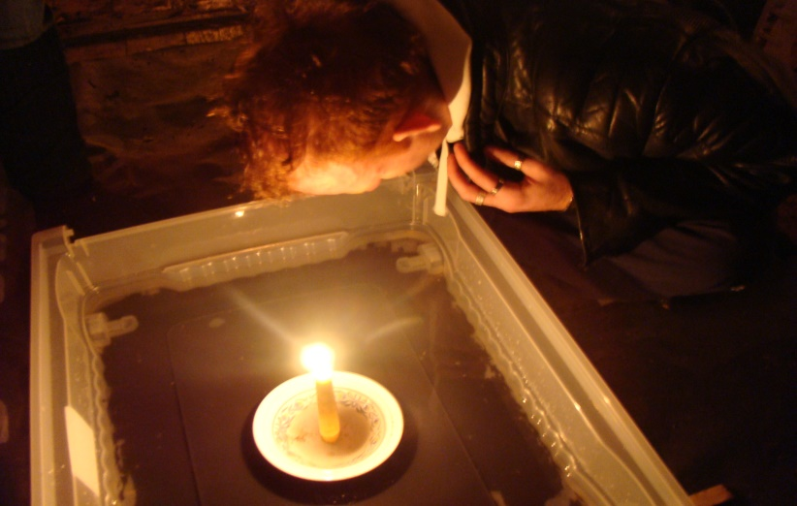
This experiment involves a candle on top of an upturned pint glass placed at the centre of square plastic tub half full with water. The base of the plastic tub is covered in black paint so a reflection can be seen in the candlelight. In an event of a séance the glass may move with the easy flow from the water. Reflections may change from looking into the water depending on the disturbed water and flickering candlelight.

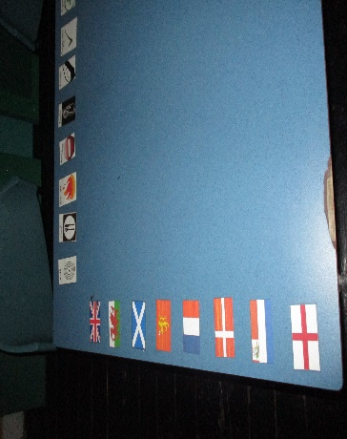
Nationality cARDS
Sometimes it is interesting to find out where the Spirit came from, if they came from abroad or if they found an alliance or enemy with certain nations. This experiment with grid reference mapping can give an ideal point of view towards how a battle happened before, during and after. Using a divination tool, we can find out what nationality the Spirit is. Along with the body mood doll and colour mood frame, we can find out how the Spirit died or felt in battle.

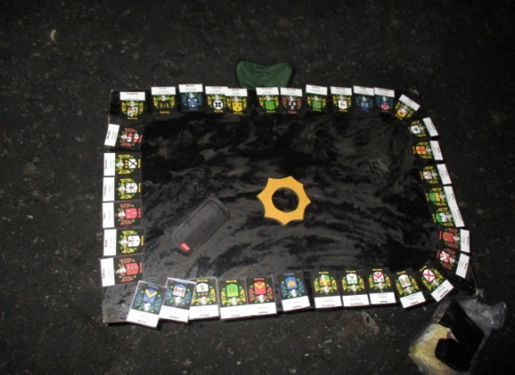
SEPT/CLAN CARDS
A sept is a division of a family. It may derive from the Latin word meaning ‘fold’ or ‘enclosure’, or from the Irish language - ‘seed’ or ‘progeny’. Many regions in Ireland were ruled by dynasties in different periods of time. Each card has its very own coat of arms and clan name. Using a divination tool, we can find out what clan represents the Spirit in contact. We can find out what areas was their stronghold by using the grid reference mapping. We can also find out who they fought and who they formed allegiance to.

DESCRIPTION CARDS
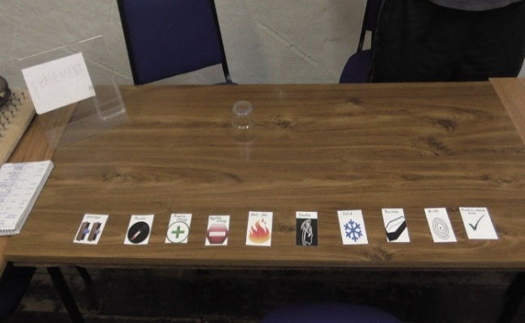
Some of these cards describe ‘Food’, ‘Hot’, ‘Cold’, ‘Burial’, ‘Active area’, to name but a few, to help build a picture of what is happening or what has happened at a particular location.
This works well with the grid reference mapping and separation vigils. Using a divination tool, we can also determine which particular areas of the building or location are different to others, to form a pattern to a possible haunting that occurs there.

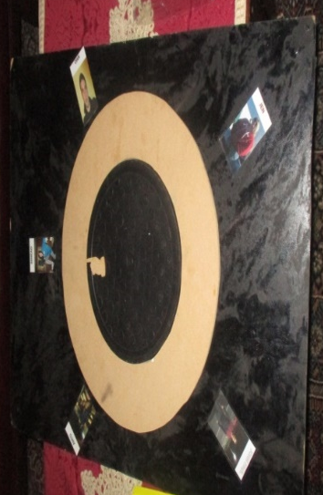
INDIVIDUAL TEAM MEMBER CARDS

Each of these cards has a picture of a team member on them. Sometimes Spirits may be attracted and seek to communicate with one particular team member. This is ideal if the team member is brave enough to be able to ask out questions – or braver still, be on their own in another part of the location for a separation vigil. By using a divination tool of choice, we can find out which person the Spirit has an interest in.

EXPERIMENT CARDS
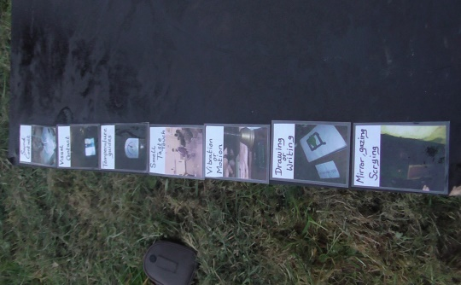
We love using different types of equipment, so why shouldn’t a Spirit feel the same way? You may come across a haunting where a certain type of phenomena occurs that leads you to using a type of gadget or doing a certain type of experiment to try and get the best sort of evidence. If a Spirit changes temperature, then a thermometer or thermal imaging camera might come in handy. If on the other hand, noises are heard then a digital recorder or a Frank’s box would prove useful. The experiment cards are used with a divination tool to see what category of contact the Spirit feels comfortable in doing. ‘Drawing or Writing’, ‘Vibration or Motion’ or ‘Smell, Taste and Touch’ are the names of just a few of the cards used in the deck.
GRID REFERENCE MAPPING
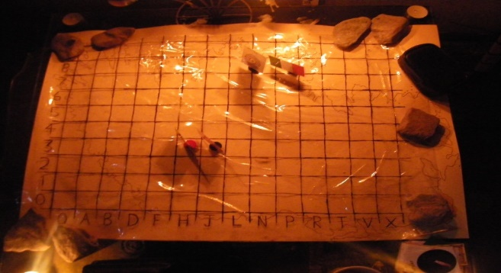
A piece of paper with a townland, building or map is employed with several grids marked on it. A vertical (numbers) and horizontal (letters) axis is used to indicate a particular area of interest.

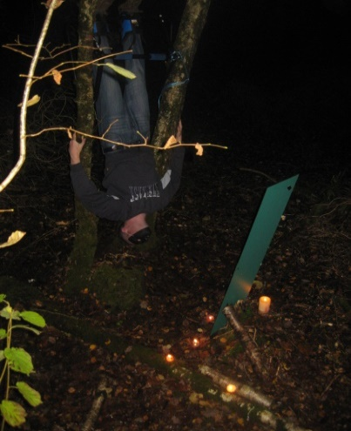
HANGMANS REFLECTION
Using a mirror for scrying, an individual is suspended in the
air with their feet on an inversion bar, supported by gravity
boots. The reason for this is to link with the Hangman Tarot Card meaning. It is an act of submission; a yielding of the mind to the universal flow, with added characteristics to human health behaviour, both for and against. Numerous other contributors can be added to make the experiment more relaxing: a mask, music and scented candles can help. Changes in the way of meditation is hard to adjust to as unfamiliar influences are quickly noticed making concentration the key.

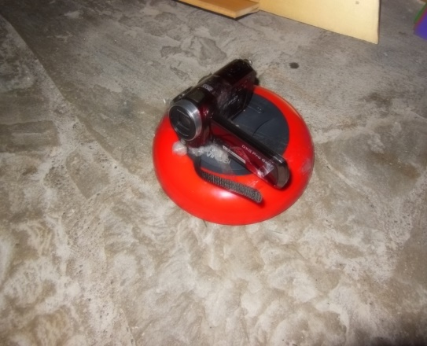
MOBILE ROBOT
This device uses ultrasonic waves to detect obstacles in its path when moving. Should anything be in its way, it alters the general line, into a clear space. This instrument is handy left in a locked off room to do its thing. Visual and sound equipment attached to it may pick up on a presence. What could prove useful are certain light objects placed on top of it. A digital sound recorder, replaying a certain sound (singing, music etc.) might attract a reaction. A small tub, test tube or container which releases a certain aroma could also be effective, or even an artefact (trigger object). It has two timer settings. One is for half an hour, the other, more generous, lasting an hour.

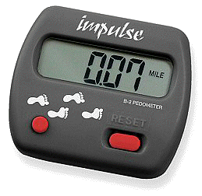
PEDOMETERS
You can come across locations which are large and spacious; you will also come across places that are small and compact. Time spent on an investigation could prove crucial too. Transporting equipment can be arduous on occasions, so keeping an eye on how much distance is covered becomes handy, especially when dealing with fatigue. Some pedometers have a reading for steps; ignore this, as people’s strides are different. Instead the mile/km reading gives a more accurate result. If you’re lucky you might come across a location where readings are too high or too low. This might be to do with something unexplainable (for an example, elapse of time in another dimension), so make sure a few team members have one on them and start and finish at the same time. Results may vary depending on how much work is done by an individual.

FOG MACHINE
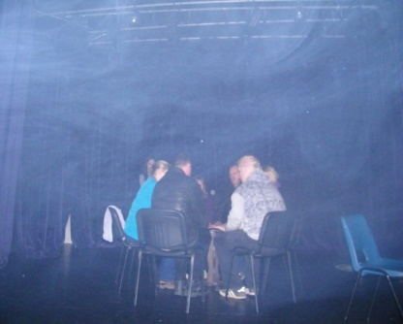
You are probably thinking of dancefloors, stage show productions, concerts or dramatic horror films! But, this is something that can be used in the paranormal. Not all places in the past had smokeless interiors. Tobacco was abundant and fires were essential part of human living. As a fog machine goes, the vapour (glycol or glycerine type fluid) when hitting room temperature forms a mist. A Spirit may use this as method to manifest, to take form or to do the opposite, to obstruct the flow. You might just see an apparition.

Electric fencing
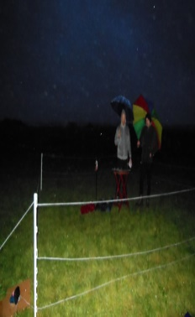
It is wise to do this experiment on a piece of land. The idea is to condense the energy inside a boundary, providing a positive active space. Four standing posts are positioned into the ground to form a shape of a square. Steel wire is wrapped between the four posts to make the outer perimeter. Afterwards, the wiring is connected to a fence energizer (providing the electrical pulses), which is attached to a ground rod (no less than two feet away) placed into the earth. An EMF meter is used to see if the electric fencing is working and a stepping board or stool is handy to get in and out of the enclosure to prevent getting a shock.
AUTOMATIC DRAWING/WRITING FIGURE VISUAL
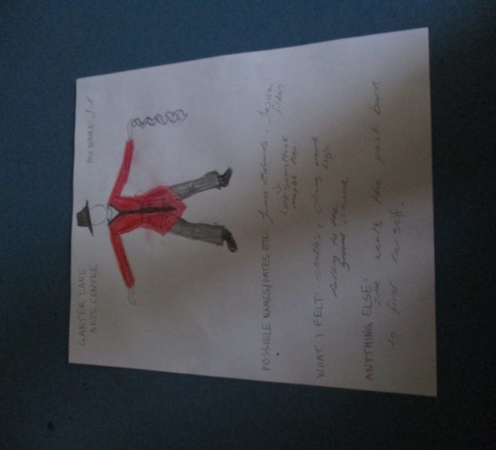
Sometimes you might sense or visualise a Spirit close by but find it hard to describe to other people what they look like. We use a figure template so individuals can accurately draw on types of clothing, facial features and accessories that they perceive the Spirit resembles. Names/dates and what the person felt at the time can be also written down. This experiment help gives us an ID of the Spirit, something that can be evaluated at a later stage. It prepares the individual to concentrate, to be in the state of mind to acquire information. Putting pen to paper makes it easier to record. Automatic drawing/writing figure visual experiment is best done in a secluded spot, away from any disturbances. It could also combine with a scrying session or quite simply, if someone has spotted what they think is a ghost.

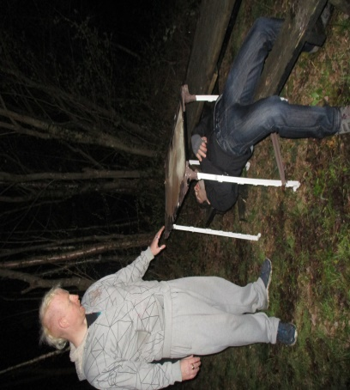
Earth catoptromancy
A method of scrying, with a mirror placed at a horizontal level reflecting down on a person. The individual is suspended above the ground, lying beneath, and parallel to the mirror above them. Looking into the mirror the individual will see their reflection and the earth around them. To the outside of the mirror, the sky above should come into view. This experiment is ideal for burial grounds.

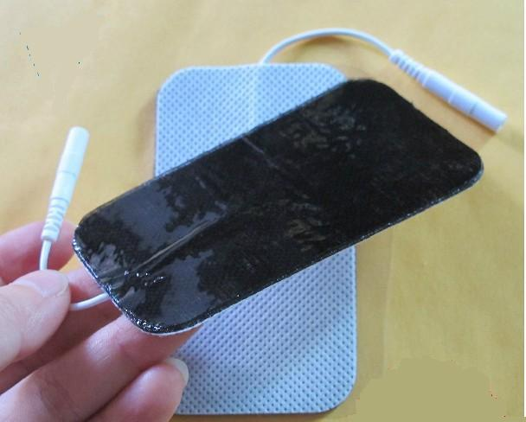
SHOCK PULSE PADS
Using electrode pads, mild electrical impulses are send through the skin into nerve fibres in the body to produce the pain killing chemicals ‘encephalin’ and ‘endorphins’. This helps stop the progress of feeling pain thanks to the morphine like material and increases the chance of happiness and pleasure possibly giving the receiver the mental state of euphoria. Worth doing in a location to aid healing.

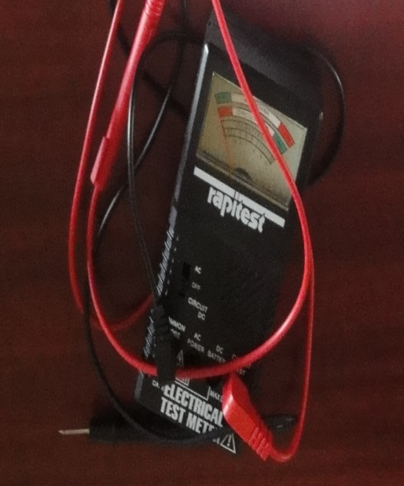
VOLTMETER
A voltmeter records the difference of electrical capacity between two points in an electric circuit. This analogue voltmeter has three settings; they are off, AC and Circuit DC. There are four slots or terminals at the bottom of the meter for common probe, AC power, DC battery and circuit test functions. One probe, black (negative) goes into the common probe terminal, and the other probe, red (positive) goes into the circuit test terminal. The voltmeter is put on a circuit DC setting. One person connects onto the black probe, another person to the red probe, then, the two people connect, hold hands with their other spare hand. Ideal for a séance or calling out vigil, a spike from the pointer of the voltmeter could occur when asking a question or during a certain period of time.
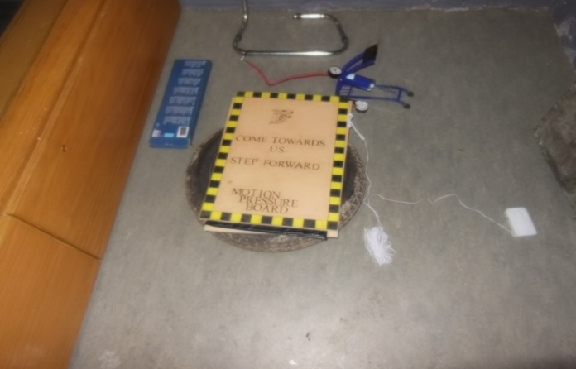
MOTION PRESSURE BOARD
Would it be interesting to measure the force or weight of a Spirit? How can footsteps or tapping be heard? The experiment consists of two boards measuring approximately (3ft by 1.5ft) that sandwich a motion pressure pad. Underneath the bottom board is a tractor tyre tube. The air pressure (kg/cm²) is measured by an air pressure gauge before and after an investigation or vigil. Weight of the surface, gravity, and force applied might offer a theory. Tests have been done in the past. In 1907, Duncan MacDougall conducted experiments based around the measurement of the human soul.
PERSONALITY TEST
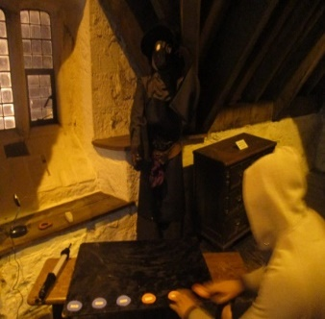
This experiment is based around the theory of Carl Gustav Jung on psychological types and later, an acronym approach by Isabel Myers and Katherine Briggs. Sixteen personalities are used to describe what an individual is like and how they go about doing things in their daily life. Sixty questions are asked with six answers to choose from: agree, mildly agree, strongly agree, disagree, mildly disagree and strongly disagree. A divination tool can be used to determine which answer the Spirit prefers.
BRAINWAVE TECHNOLOGY
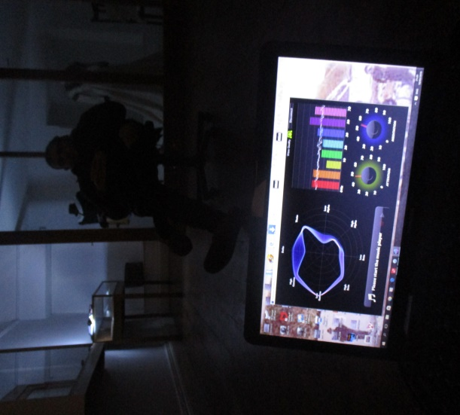
The MindWave Mobile from NeuroSky specialises in using Electroencephalography (EEG) - technology in collecting information from the brains electrical activity. Attached to the headset is an ear clip which has reference and ground electrodes, to measure voltage. The sensor arm has the EEG electrode which can be positioned in front of the frontal lobe. The device measures from 0Hz – 70Hz, the Delta, Theta, Alpha, Beta and majority of Gamma brain waves. We are able to see how much an individual can get into an attention and meditative state on their own in a particular spot and how they cope should a make Spirit contact. Sight, sound and touch can stimulate electrical activity. The device can also pick up on an individual blinking. Eyes closing, is a positive peak and eyes opening, is a negative peak on the graph.

WATER Submersion test
Not all hauntings happen on land. Water covers nearly three quarters of the surface of our world. It is known for its purity, cleansing and is a vital necessity to all known forms of life on this planet. Honored, it can also claim mortal beings and transport carriers, due to unforeseen and tragic circumstances. Some bodies might never be recovered and left at the bottom of the sea (Davy Jones Locker). Mythological stories of sea, lake or river monsters may have been far-fetched but there may have been logic behind them. The tales of sunken cities can’t be ruled out either. This experiment involves being in shallow water, up to knee height, with just enough depth to lie down and rest the back of the head. The chin is slightly tilted upwards to allow flow of air to the lungs. Controlled breathing is aided by a snorkel while a nose clip preventing any water coming through the nose. Goggles are also a welcome addition. When relaxed, it is possible to get into a meditative state. The test can last up to about ten minutes, depending on the individual, temperature of water and other factors and can work well on its own or with separate experiments happening nearby at the same time, involving other group members.
MAGLEV
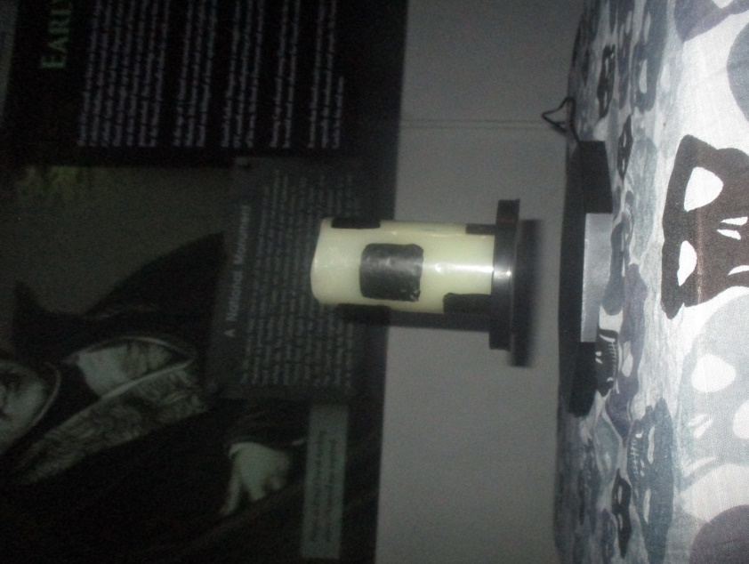
This levitation apparatus purpose is to make an object float, by using magnets. The octagonal base contains electromagnetic elements to stabilize, and locks onto a carrier ring by a sensor. An object, such as battery powered candle can be placed on the carrier ring. Trigger objects can be used, such as keys, coins etc. The lighter the object, the further floating distance can be accomplished between the base and the carrier ring. This system can be used during scrying or séance experiment, yet it is recommended to keep it at a distance from magnetic sensitive objects due to the magnetic field it generates. When calling out, you can ask the Spirit to rotate the instrument, slow or speed the process of rotation, or better still, to interrupt the floating space between the base and carrier ring, sending the ring down onto the base with force.

IDENTITY TEST
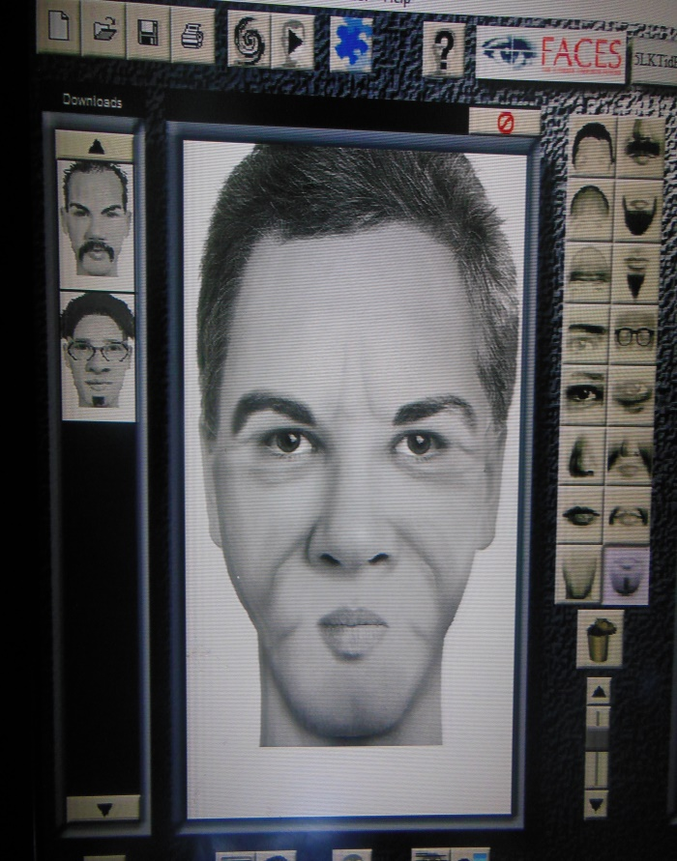
Award-winning facial composite software devised by IQ Biometrix. Used by law enforcement agencies worldwide in criminal investigations; it can prove vital in bringing criminals to justice, and also helps children in developing their observation skills. It can be used in the paranormal field too. An eye-witness can give a better account on what they have seen or sensed (apparition) by putting a face to the Spirit. Divination tools, ranging from a pendulum, glass or planchette can be effective in the presence of an intelligent/responsive Spirit. A comprehensive image of the Spirit could be produced by going over the various facial features such as hair, nose, and smile lines and so on. The technology is easy to use; and the resemblance of the Spirit can be saved and furthermore printed.
TRIGGER WORDS (BRAIN ACTIVITY AND SURVIVAL)

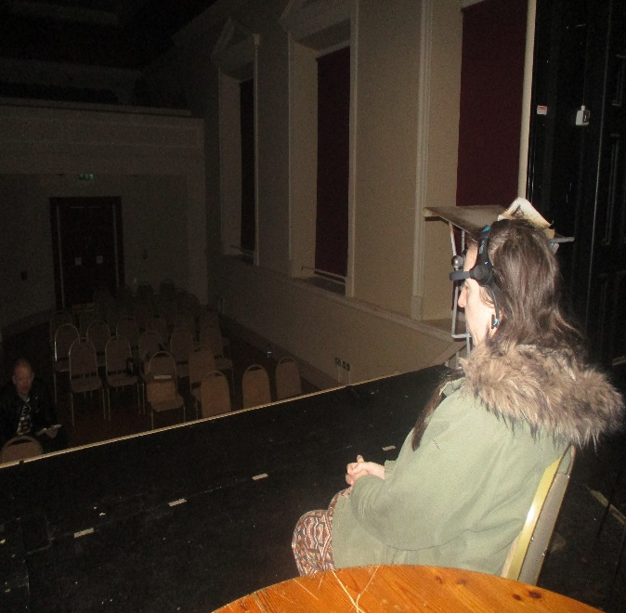
Communication has a huge role in our daily life’s. We use names to introduce ourselves, warn of danger. Some words are happy or displeasing to some people. Others, can evoke a fond or terrible memory. How we pronounce words, at which amplitude (whisper or shout) can be crucial. Not to mention, the meaning of such words can change over time. ‘Power Words’ are utilized by hypnotists, whilst chanting in unison has a massive social influence. This experiment is to see how our minds are effected in processing emotional driven words, especially during calling-out sessions. A test subject is asked to submit five positive and five negative words (trigger words) they use in their daily life’s prior to the experiment. An EEG (electroencephalogram) device which measures brain activity is attached to the same individual’s head. The ten words in total (trigger words) are integrated with other words to form a question or a statement. These (trigger word) questions or statements will be spoken out at different stages of the calling-out session along with other control (non-trigger word) questions and statements. The EEG device will measure the strength of all five brainwaves (Delta, Theta, Alpha, Beta and Gamma) in the post-five seconds of a trigger word being spoken. The theory is that the individual’s brain activity will display a variation between trigger words and control words. To test for survival (life after death) and for differences between positively and negatively spoken words, we ask for five positive and five negative words from a ‘Spirit’ in an Ouija board session. An individual (secluded from the Ouija board session) will be tested using an EEG device to see if any ‘Spirit’ can channel through them and use their mental capabilities. On this occasion, only the ten trigger words (positive and negative) are amalgamated into sentences to form a question or statement. They will be relayed by a loud speaker to the individual who is alone in a reputedly haunted room/area of the site. There will be no control statements or sentences this time, instead, we monitor the post-five seconds of a positive and negative word being said. It is a probable that the person or ‘Spirit’ will be highly stimulated by the positive words rather than the negative words. It begs the question, although our memory tends to recount a bad or horrible memory it mainly tends to only flicker and pass by these experiences for the main proportion of the population. Nicer memories are more fondly revived, but then it might just come down to what out-weighs the other. If someone is aware of their trauma all the time; even pain, then a little communication or chat about that sensation or feeling can do a lot to bring someone out of the gloom, put it aside for moment, and even revitalise; bring them back to life.

Brain Segment Experiment

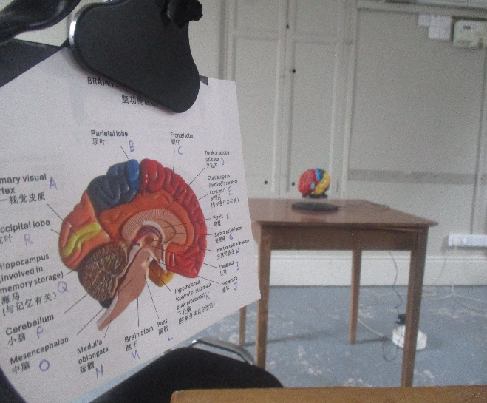
This test is designed to focus primarily on the complex organ that controls all the functions of the body, including our senses, thought, memory, emotion, motor skills (movement), temperature and every other process that manages our anatomy – the brain (or the cerebrum). However, the test can be practically used to reach out beyond the fabric of knowledge that we associate with it. To do this, a card is twinned with an anatomical life-sized colour-coded model of the brain for the experiment. The card is labelled on both sides with a diagram for the internal part of the brain on one side, and external on the other, along with the wording/name that corresponds to a certain coloured part of the model. Each name (part of the brain – twenty-eight in total) on the card has a letter from the alphabet (or the number 1 or 2) written next to it. With a talking board, we can ask the Spirit world various questions, such as, how our brain operates in our daily lives, how it intergrades with their realm, or adjusts to differing circumstances (for instance death), in particular, regions that may be still active in a posthumous state, and so on. By using a planchette (or glass), a letter (or the number 1 or 2) might be singled-out as an answer to a specific question.

