LOCATIONS 2017
Lanyon Tunnels
County Antrim
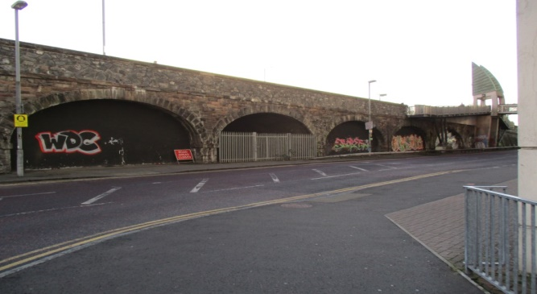
The Lanyon Tunnels sit beneath East Bridge Street in Belfast city centre. Eight arched tunnels flank a railway track that leads into Central Station. They were originally used as holding pens for cattle on their way to the abattoir in Stewart Street, which leads off East Bridge Street. The tunnels were built around the 1860s after the East Bridge collapsed due to the weight of carts, livestock and horses.

Bawnboy Workhouse
County Cavan
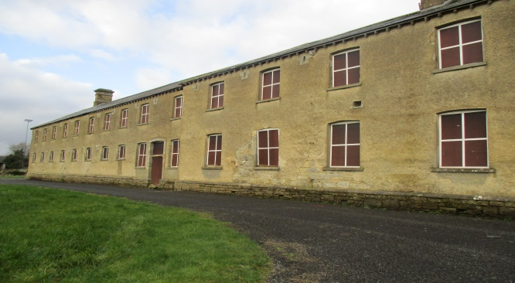
Bawnboy is a small village in County Cavan. The Workhouse was estimated to have been built around 1850 – 1853. Its structure was to seclude inmates with its high walls. It was designed by the Poor Law commissioner’s architect, George Wilkinson. It served to hold five hundred inmates, although it didn’t even house half that number in its entire history. It was opened in late 1853, eventually closing down in 1921. There was strict discipline at the Workhouse with reports of skirmishes.

Ballinagarde House
County Limerick
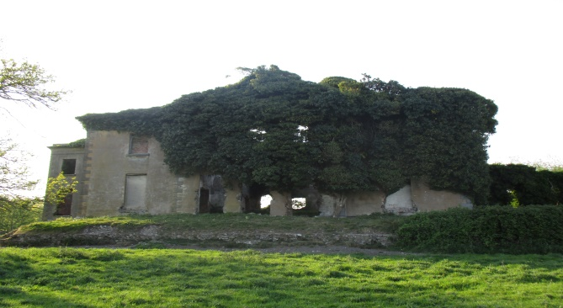
Ballinagarde House, a Georgian building, was built by Edward Croker (1706-1780) in the 1700s. The Croker’s were an illustrious family. Edward Croker (grandson of Edward Croker who built the house) became bankrupt. He is noted as being, ‘A worthless spendthrift who brought up an arrogant race of blockheads of both sexes’. Edward Croker of Ballinagarde, and his son, John (1730-1795) are pictured in a Limerick Hellfire club portrait.
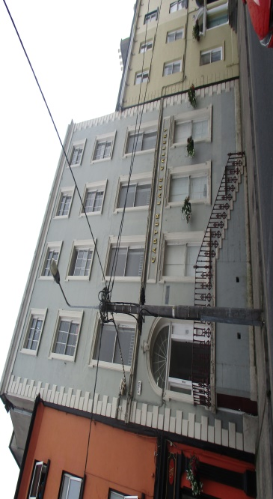
Garter Lane Theatre
County Waterford
The Garter Lane Arts Centre opened its doors on the 8th September, 1984. 22A O’Connell Street was built in 1792; the two storey building was used as a Quaker Meeting House (a meeting place for worship) for the Christian group. It served as Waterford Courthouse in the 1970s. 5 O’ Connell Street is situated in the former Georgian four storey townhouse of Samuel Barker, the Mayor of Waterford City in 1737. The house was built in-between 1720 – 1740. Samuel Barker was a rich Quaker Banker and Merchant.

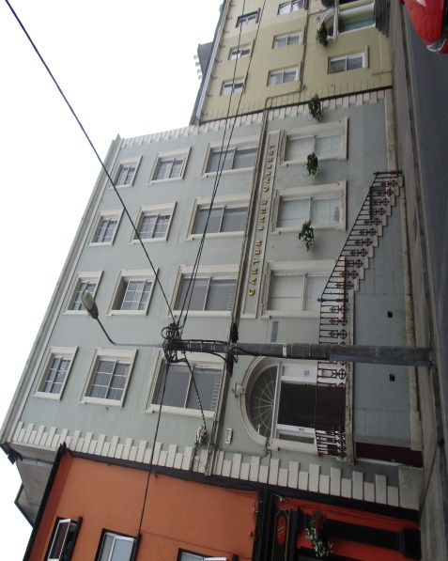
Fairbanks House
Dedham, Massachusetts, United States of America
(See Universal page).

Ross Castle
County Meath
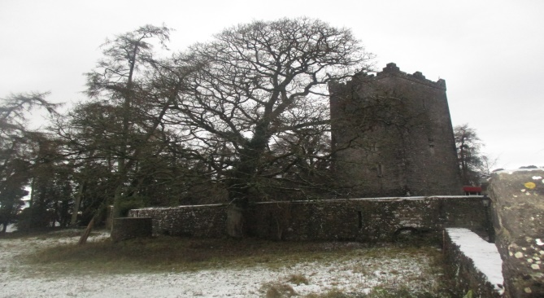
The Castle of Ross is close to Lough Sheelin in County Meath. Built around 1537 by Richard Nugent (12th Baron of Devlin) as a safeguard from Irish Septs, Ross Castle now serves as a seven bedroom bed and breakfast. The Great Hall, the entrance into the building was completed by Richard Nugent’s grandson, also named, Sir Richard Nugent (13th Baron of Devlin) in 1539. A plaque (created by Anna Maria O’ Reilly in 1864) up on the wall in the Great Hall commemorates a Myles O’ Reilly, otherwise known as, ‘The Slasher’ who was to spend his last night at the Castle before the Battle of Finea in 1644.

