LIGHTING
LASER TALKING BOARD
This is a semi circled talking board with twenty-nine vertical pieces of wood positioned at the edge. Inscribed on the inside of each piece of wood is a letter from the Theban alphabet (ancient Greek, popular with occultists). The words 'Yes', 'No' and ‘Change’ are also featured. In the middle of the board is a circular dial with a red laser pen located on the rim. The dial can rotate clockwise or counter-clockwise when individuals connect on it. When asking certain questions, the light from the laser may point to a certain letter or word around the board. It is effective when used in the dark.
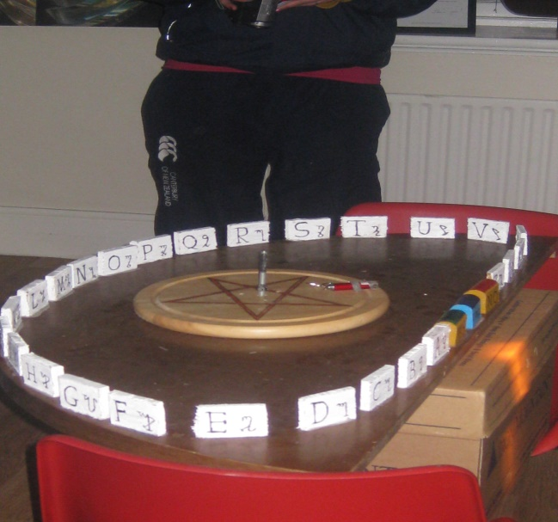
Strobe lighting
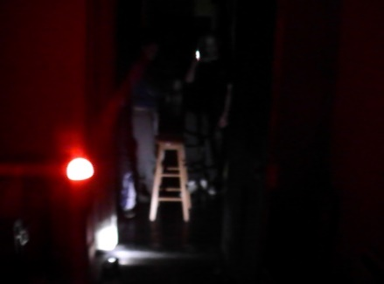
When working in the darkest of locations strobe lighting can bring in some added exposure. Some strobe lighting appliances come with many special features – such as different colours to illumine the area/room; the speed in which the light flashes, or sequences, and other modes. Using the light as bate could trigger a reaction in some shape or form. The lightning effect may make you see shadows. It might heighten that sense of fear that brings in that energy.
Plasma lamp
Nikola Tesla invented the first plasma lamp. By using the (RF)
radio frequency power from the lamp, it produces a waveguide
that constricts and focuses on putting the electrical field
into plasma. The plasma lamp does create considerable EMF.
Modern day lamps can trigger differences by sound and touch.
The plasma lamp is a handy tool for bringing in energies into
a séance, although it is a great energy saver that produces
less wattage than other types of lighting.

LASER BEAM MACHINE
The Laser beam acts as a type of portal for the Spirit world. It can emit three colours, red, green and yellow, and can be programmed for the same three colours to be used at the same time also. Numerous sequences of shapes are shone in various directions, at several different speeds onto a wall or surface. It is most effective when used in a darkened area, pointed at a certain object or area of interest with a visual recording device (video camera) set up in view.
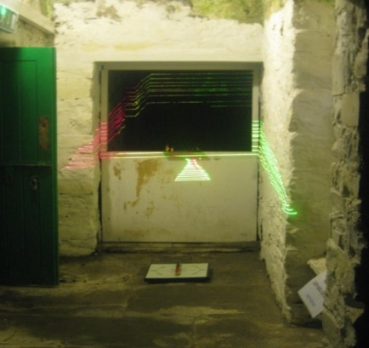
SHADOW PLAY FIGURES
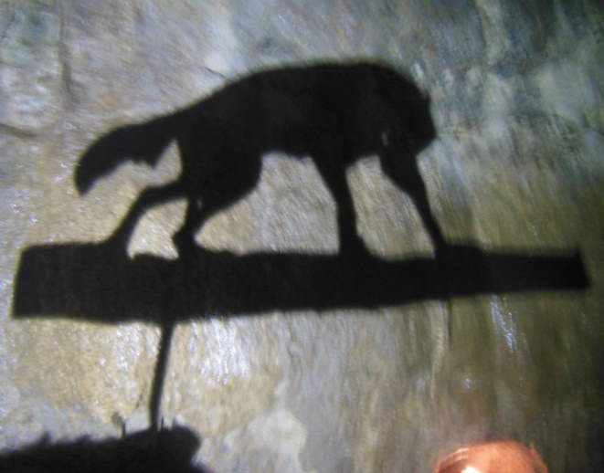
Shadow play is a type of entertainment which involves storytelling. It is thought to have originated as far back as 1AD in Southeast Asia, and first became popular in Europe in the 17th century. A light source (such as a torch) is shone onto a piece of card (shaped, to represent a particular character) creating a shadow onto a surface behind it. This experiment works well as a type of past enactment, in a location with a diverse history compared to other places and with possible spectres of children.
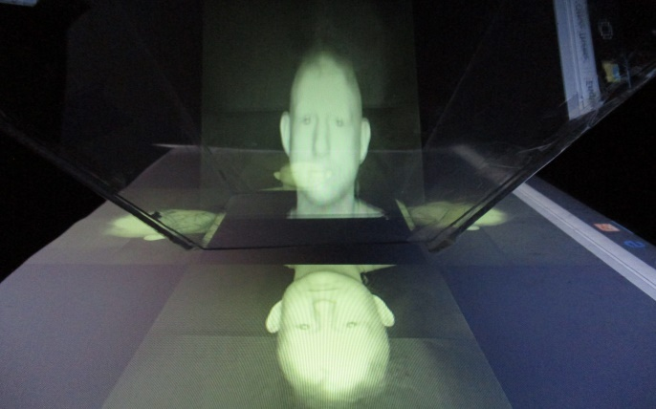
HOLOGRAPHY
It is known as the science of creating a photographic recording, from scattered or impeding light (we used a plasma TV) which diffracts (using an upturned clear Perspex four sided trapezoid shape), bending the light to make a 3D pattern. A 2D recording is emitted on each side off the Perspex shape (all equal in time, illumination and size). This is ideal for presenting past footage to the Spirit world or for calling out and past enactment experiments.

Offering of fire
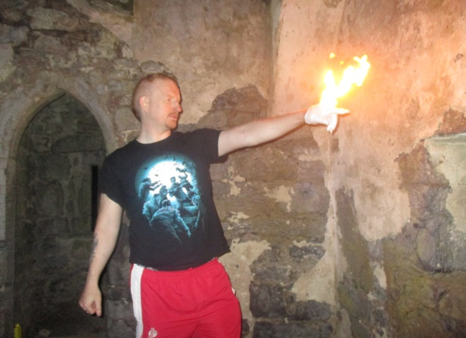
Fire has been used by humans for thousands of years as a source for heating food, thus reducing disease, also, helping to keep warm in cooler climates and for the light it produces, to warn off predators and to guide. Two fire gloves (left and right) are soaked in water, squeezed to semi-dry, and then fitted on each hand. The second pair is worn over the first pair and a very small amount of lighter fuel is dripped onto the inside palm and the finger tips. When lit, the combustion period lasts for about twenty seconds.

