LOCATIONS 2013
Kilcrea Friary
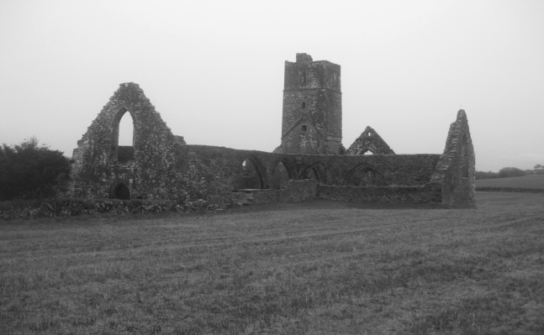
County Cork
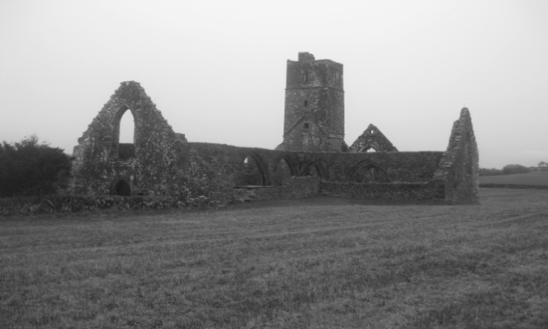
The meaning is 'Church of Cre' or 'Cell of Cyra' after Saint Cyra who formed a nunnery nearby in the 6th century. Built and overseen by Chieftain Cormac McCarthy the Franciscan Observant Friars occupied the Friary in 1465. Notable exchanges of ownership changed with Dissolution of the Monasteries and Parliamentarian movement until it became property of the Public board of Works in 1882.

The Strand Inn Hotel
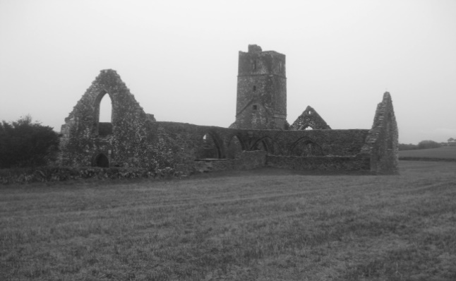
County Waterford
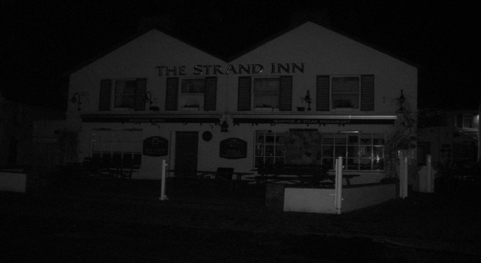
A great Fishing tradition surrounds the Strand Inn Hotel location in Dunmore East, Co Waterford. The building is said to be 300 years old. The word Dun Mor means 'Old Fort'. Where the Strand Inn is now used to be the old launching site for boats. Seafood meals are served along with a beautiful view of the Hook Head peninsula next to Blue flag sandy beaches.

Loophead Lighthouse and Keepers Cottages
County Clare
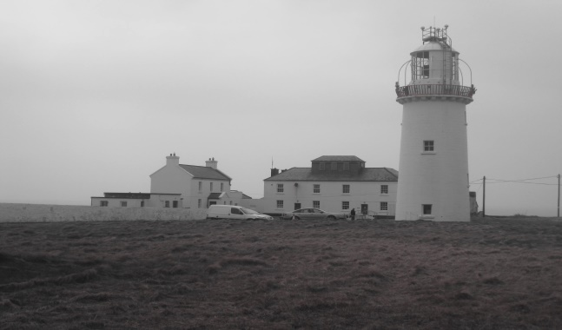
Standing tall in Kilbaha, County Clare Loophead Lighthouse was constructed by George Halpin in 1854.Former Lighthouse was built on the site around 1670. A scenic location with battered clifftops and supreme wildlife flock its perimeter walls. A museum is featured in the Keepers Cottages and guided tours can be done at the Lighthouse.
Arts @ Civic Trust House
County Cork
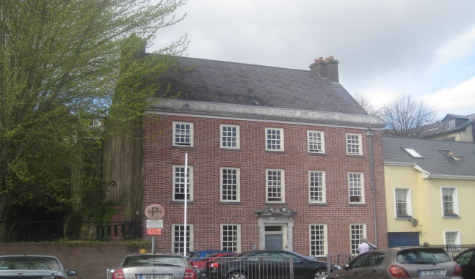
Thought to be the oldest house in Cork City this red bricked structure was originally built for the dwelling of the 4th Earl of Cork in-between 1700-1730. Formally a Hospital for Women and Children in the late 1800s and at the end of the last century a theatre inhabited the building. It is now owned by Cork City Council which accommodates local organizations in the field of the arts.

Smock Alley Theatre
County Dublin
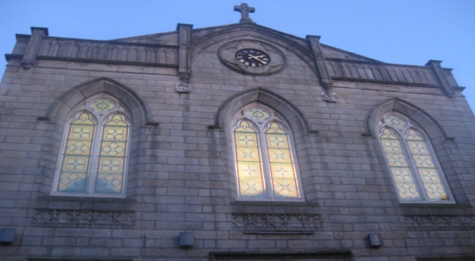
Smock Alley was built in 1662 and is situated on Exchange Street, Templebar in Dublin city centre. It is 'the oldest/newest theatre of Ireland'. It became a church in the mid 1820's. Falling parish numbers led to the deconsecrating of the Church and in 2012 with restoration it became a theatre again. Famous 18th century actor David Garrick played Hamlet here. A Crypt is also a feature of the building.

Beal a Ghlnanna and Rathancaiscig Woods
County Cork
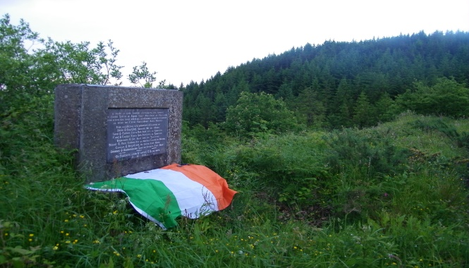
Beal a Ghleanna means 'Mouth of the Glen' in Irish. On the 8th July 1918 an ambush occurred on the road linking Ballingeary to Ballinvourney. Two RIC officers were confronted by seven Irish Volunteers. One RIC officer was shot in the neck in the struggle but there were no fatalities. This was the first engagement since the 1916 Easter rising. The standing stones are situated in Rathancaiscig Woods.

Rock Island Napoleonic Signal Tower
County Cork
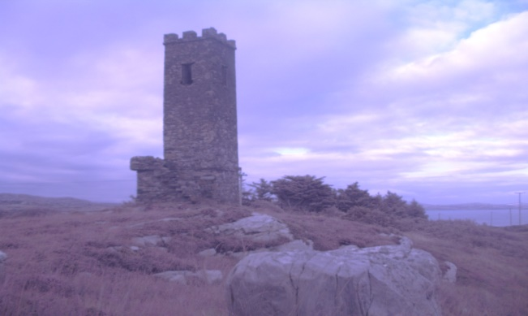
Rock Island is surrounded three sides by sea but is connected by a small bridge to the mainland. Crookhaven Lighthouse is sited at the island. Guglielmo Marconi did many of his wireless telegraph communication experiments around this area. This was the spot the Titanic was last seen from. The Napoleonic Signal Tower on this site reaches a height of 50 feet on a rock mount base.

Applerock Studios
County Dublin
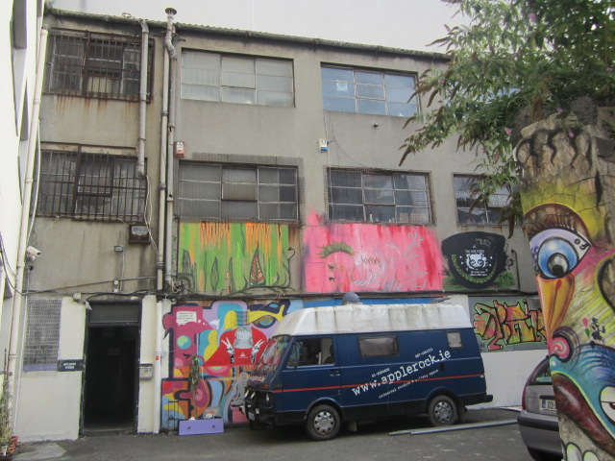
State of the art recording studios situated on the old 'Monto' on Foley Street in Dublin city. This was a notorious area from 1860-1920 as being the biggest red light district in Europe. A total of 1,600 Prostitutes worked on Montgomery Street in its heyday. Famous visitors to the area were James Joyce and King Edward VII. It used to be an area called the 'Smothering Den' where people were put to death.

